> library(tidyverse)

-- Attaching packages --------------------------------------- tidyverse 1.3.0 --

v ggplot2 3.3.2 v purrr 0.3.4

v tibble 3.0.3 v dplyr 1.0.2

v tidyr 1.1.2 v stringr 1.4.0

v readr 1.3.1 v forcats 0.5.0

-- Conflicts ------------------------------------------ tidyverse_conflicts() --

x dplyr::filter() masks stats::filter()

x dplyr::lag() masks stats::lag()

> library(ggplot2)

> library(tibble)

> getwd()

[1] "C:/Users/Admin/Documents"

> #setwd("C:\\Users\\Admin\\Desktop\\sample")

> setwd("C:\\Users\\Admin\\Desktop\\sample")

> getwd()

[1] "C:/Users/Admin/Desktop/sample"

> Sample=read.csv("SampleSuperstore.csv")

> Sample

Ship.Mode Segment Country City State

1 Second Class Consumer United States Henderson Kentucky

2 Second Class Consumer United States Henderson Kentucky

3 Second Class Corporate United States Los Angeles California

4 Standard Class Consumer United States Fort Lauderdale Florida

5 Standard Class Consumer United States Fort Lauderdale Florida

6 Standard Class Consumer United States Los Angeles California

7 Standard Class Consumer United States Los Angeles California

8 Standard Class Consumer United States Los Angeles California

9 Standard Class Consumer United States Los Angeles California

10 Standard Class Consumer United States Los Angeles California

11 Standard Class Consumer United States Los Angeles California

12 Standard Class Consumer United States Los Angeles California

13 Standard Class Consumer United States Concord North Carolina

14 Standard Class Consumer United States Seattle Washington

15 Standard Class Home Office United States Fort Worth Texas

16 Standard Class Home Office United States Fort Worth Texas

17 Standard Class Consumer United States Madison Wisconsin

18 Second Class Consumer United States West Jordan Utah

19 Second Class Consumer United States San Francisco California

20 Second Class Consumer United States San Francisco California

21 Second Class Consumer United States San Francisco California

22 Standard Class Corporate United States Fremont Nebraska

23 Standard Class Corporate United States Fremont Nebraska

24 Second Class Consumer United States Philadelphia Pennsylvania

25 Standard Class Consumer United States Orem Utah

26 Second Class Consumer United States Los Angeles California

27 Second Class Consumer United States Los Angeles California

28 Standard Class Consumer United States Philadelphia Pennsylvania

29 Standard Class Consumer United States Philadelphia Pennsylvania

30 Standard Class Consumer United States Philadelphia Pennsylvania

31 Standard Class Consumer United States Philadelphia Pennsylvania

32 Standard Class Consumer United States Philadelphia Pennsylvania

33 Standard Class Consumer United States Philadelphia Pennsylvania

34 Standard Class Consumer United States Philadelphia Pennsylvania

35 Second Class Home Office United States Houston Texas

36 First Class Corporate United States Richardson Texas

37 First Class Corporate United States Richardson Texas

38 Standard Class Home Office United States Houston Texas

39 Standard Class Home Office United States Houston Texas

40 Standard Class Home Office United States Houston Texas

41 Standard Class Home Office United States Houston Texas

42 Standard Class Corporate United States Naperville Illinois

43 Standard Class Corporate United States Los Angeles California

44 Standard Class Corporate United States Melbourne Florida

45 First Class Corporate United States Eagan Minnesota

46 First Class Corporate United States Eagan Minnesota

47 Second Class Consumer United States Westland Michigan

48 Standard Class Consumer United States Dover Delaware

49 Standard Class Consumer United States Dover Delaware

50 Standard Class Consumer United States New Albany Indiana

51 Standard Class Consumer United States New Albany Indiana

52 Standard Class Consumer United States New Albany Indiana

53 Standard Class Consumer United States New Albany Indiana

54 Standard Class Corporate United States New York City New York

55 Standard Class Corporate United States New York City New York

56 First Class Consumer United States Troy New York

57 First Class Consumer United States Troy New York

58 First Class Consumer United States Troy New York

59 First Class Consumer United States Troy New York

60 First Class Consumer United States Troy New York

61 First Class Consumer United States Troy New York

62 First Class Consumer United States Troy New York

63 Standard Class Consumer United States Los Angeles California

64 Standard Class Consumer United States Los Angeles California

65 Standard Class Consumer United States Los Angeles California

66 Standard Class Consumer United States Los Angeles California

67 Standard Class Home Office United States Chicago Illinois

68 Standard Class Corporate United States Gilbert Arizona

69 Standard Class Corporate United States Gilbert Arizona

70 First Class Consumer United States Springfield Virginia

71 Standard Class Consumer United States New York City New York

72 Second Class Consumer United States Jackson Michigan

73 Standard Class Consumer United States Memphis Tennessee

74 Standard Class Consumer United States Memphis Tennessee

75 Standard Class Consumer United States Memphis Tennessee

76 First Class Corporate United States Houston Texas

Postal.Code Region Category Sub.Category Sales Quantity Discount

1 42420 South Furniture Bookcases 261.9600 2 0.00

2 42420 South Furniture Chairs 731.9400 3 0.00

3 90036 West Office Supplies Labels 14.6200 2 0.00

4 33311 South Furniture Tables 957.5775 5 0.45

5 33311 South Office Supplies Storage 22.3680 2 0.20

6 90032 West Furniture Furnishings 48.8600 7 0.00

7 90032 West Office Supplies Art 7.2800 4 0.00

8 90032 West Technology Phones 907.1520 6 0.20

9 90032 West Office Supplies Binders 18.5040 3 0.20

10 90032 West Office Supplies Appliances 114.9000 5 0.00

11 90032 West Furniture Tables 1706.1840 9 0.20

12 90032 West Technology Phones 911.4240 4 0.20

13 28027 South Office Supplies Paper 15.5520 3 0.20

14 98103 West Office Supplies Binders 407.9760 3 0.20

15 76106 Central Office Supplies Appliances 68.8100 5 0.80

16 76106 Central Office Supplies Binders 2.5440 3 0.80

17 53711 Central Office Supplies Storage 665.8800 6 0.00

18 84084 West Office Supplies Storage 55.5000 2 0.00

19 94109 West Office Supplies Art 8.5600 2 0.00

20 94109 West Technology Phones 213.4800 3 0.20

21 94109 West Office Supplies Binders 22.7200 4 0.20

22 68025 Central Office Supplies Art 19.4600 7 0.00

23 68025 Central Office Supplies Appliances 60.3400 7 0.00

24 19140 East Furniture Chairs 71.3720 2 0.30

25 84057 West Furniture Tables 1044.6300 3 0.00

26 90049 West Office Supplies Binders 11.6480 2 0.20

27 90049 West Technology Accessories 90.5700 3 0.00

28 19140 East Furniture Bookcases 3083.4300 7 0.50

29 19140 East Office Supplies Binders 9.6180 2 0.70

30 19140 East Furniture Furnishings 124.2000 3 0.20

31 19140 East Office Supplies Envelopes 3.2640 2 0.20

32 19140 East Office Supplies Art 86.3040 6 0.20

33 19140 East Office Supplies Binders 6.8580 6 0.70

34 19140 East Office Supplies Art 15.7600 2 0.20

35 77095 Central Office Supplies Paper 29.4720 3 0.20

36 75080 Central Technology Phones 1097.5440 7 0.20

37 75080 Central Furniture Furnishings 190.9200 5 0.60

38 77041 Central Office Supplies Envelopes 113.3280 9 0.20

39 77041 Central Furniture Bookcases 532.3992 3 0.32

40 77041 Central Furniture Chairs 212.0580 3 0.30

41 77041 Central Technology Phones 371.1680 4 0.20

42 60540 Central Technology Phones 147.1680 4 0.20

43 90049 West Office Supplies Storage 77.8800 2 0.00

44 32935 South Office Supplies Storage 95.6160 2 0.20

45 55122 Central Technology Accessories 45.9800 2 0.00

46 55122 Central Office Supplies Binders 17.4600 2 0.00

47 48185 Central Office Supplies Storage 211.9600 4 0.00

48 19901 East Technology Accessories 45.0000 3 0.00

49 19901 East Technology Phones 21.8000 2 0.00

50 47150 Central Office Supplies Binders 38.2200 6 0.00

51 47150 Central Office Supplies Labels 75.1800 6 0.00

52 47150 Central Furniture Furnishings 6.1600 2 0.00

53 47150 Central Furniture Chairs 89.9900 1 0.00

54 10024 East Office Supplies Fasteners 15.2600 7 0.00

55 10024 East Technology Phones 1029.9500 5 0.00

56 12180 East Office Supplies Storage 208.5600 6 0.00

57 12180 East Office Supplies Paper 32.4000 5 0.00

58 12180 East Furniture Chairs 319.4100 5 0.10

59 12180 East Office Supplies Paper 14.5600 2 0.00

60 12180 East Technology Accessories 30.0000 2 0.00

61 12180 East Office Supplies Binders 48.4800 4 0.20

62 12180 East Office Supplies Art 1.6800 1 0.00

63 90004 West Technology Accessories 13.9800 2 0.00

64 90004 West Office Supplies Binders 25.8240 6 0.20

65 90004 West Office Supplies Paper 146.7300 3 0.00

66 90004 West Furniture Furnishings 79.7600 4 0.00

67 60610 Central Furniture Chairs 213.1150 5 0.30

68 85234 West Office Supplies Art 1113.0240 8 0.20

69 85234 West Technology Phones 167.9680 4 0.20

70 22153 South Office Supplies Paper 75.8800 2 0.00

71 10009 East Office Supplies Binders 4.6160 1 0.20

72 49201 Central Office Supplies Paper 19.0500 3 0.00

73 38109 South Furniture Chairs 831.9360 8 0.20

74 38109 South Furniture Furnishings 97.0400 2 0.20

75 38109 South Office Supplies Storage 72.7840 1 0.20

76 77041 Central Office Supplies Binders 1.2480 3 0.80

Profit

1 41.9136

2 219.5820

3 6.8714

4 -383.0310

5 2.5164

6 14.1694

7 1.9656

8 90.7152

9 5.7825

10 34.4700

11 85.3092

12 68.3568

13 5.4432

14 132.5922

15 -123.8580

16 -3.8160

17 13.3176

18 9.9900

19 2.4824

20 16.0110

21 7.3840

22 5.0596

23 15.6884

24 -1.0196

25 240.2649

26 4.2224

27 11.7741

28 -1665.0522

29 -7.0532

30 15.5250

31 1.1016

32 9.7092

33 -5.7150

34 3.5460

35 9.9468

36 123.4737

37 -147.9630

38 35.4150

39 -46.9764

40 -15.1470

41 41.7564

42 16.5564

43 3.8940

44 9.5616

45 19.7714

46 8.2062

47 8.4784

48 4.9500

49 6.1040

50 17.9634

51 35.3346

52 2.9568

53 17.0981

54 6.2566

55 298.6855

56 52.1400

57 15.5520

58 7.0980

59 6.9888

60 3.3000

61 16.3620

62 0.8400

63 6.1512

64 9.3612

65 68.9631

66 22.3328

67 -15.2225

68 111.3024

69 62.9880

70 35.6636

71 1.7310

72 8.7630

73 -114.3912

74 1.2130

75 -18.1960

76 -1.9344

[ reached 'max' / getOption("max.print") -- omitted 9918 rows ]

> Sample<-as.tibble(Sample)

Warning message:

`as.tibble()` is deprecated as of tibble 2.0.0.

Please use `as_tibble()` instead.

The signature and semantics have changed, see `?as_tibble`.

This warning is displayed once every 8 hours.

Call `lifecycle::last_warnings()` to see where this warning was generated.

> Sample

# A tibble: 9,994 x 13

Ship.Mode Segment Country City State Postal.Code Region Category Sub.Category

<chr> <chr> <chr> <chr> <chr> <int> <chr> <chr> <chr>

1 Second C~ Consum~ United~ Hend~ Kent~ 42420 South Furnitu~ Bookcases

2 Second C~ Consum~ United~ Hend~ Kent~ 42420 South Furnitu~ Chairs

3 Second C~ Corpor~ United~ Los ~ Cali~ 90036 West Office ~ Labels

4 Standard~ Consum~ United~ Fort~ Flor~ 33311 South Furnitu~ Tables

5 Standard~ Consum~ United~ Fort~ Flor~ 33311 South Office ~ Storage

6 Standard~ Consum~ United~ Los ~ Cali~ 90032 West Furnitu~ Furnishings

7 Standard~ Consum~ United~ Los ~ Cali~ 90032 West Office ~ Art

8 Standard~ Consum~ United~ Los ~ Cali~ 90032 West Technol~ Phones

9 Standard~ Consum~ United~ Los ~ Cali~ 90032 West Office ~ Binders

10 Standard~ Consum~ United~ Los ~ Cali~ 90032 West Office ~ Appliances

# ... with 9,984 more rows, and 4 more variables: Sales <dbl>, Quantity <int>,

# Discount <dbl>, Profit <dbl>

> df=Sample

> df

# A tibble: 9,994 x 13

Ship.Mode Segment Country City State Postal.Code Region Category Sub.Category

<chr> <chr> <chr> <chr> <chr> <int> <chr> <chr> <chr>

1 Second C~ Consum~ United~ Hend~ Kent~ 42420 South Furnitu~ Bookcases

2 Second C~ Consum~ United~ Hend~ Kent~ 42420 South Furnitu~ Chairs

3 Second C~ Corpor~ United~ Los ~ Cali~ 90036 West Office ~ Labels

4 Standard~ Consum~ United~ Fort~ Flor~ 33311 South Furnitu~ Tables

5 Standard~ Consum~ United~ Fort~ Flor~ 33311 South Office ~ Storage

6 Standard~ Consum~ United~ Los ~ Cali~ 90032 West Furnitu~ Furnishings

7 Standard~ Consum~ United~ Los ~ Cali~ 90032 West Office ~ Art

8 Standard~ Consum~ United~ Los ~ Cali~ 90032 West Technol~ Phones

9 Standard~ Consum~ United~ Los ~ Cali~ 90032 West Office ~ Binders

10 Standard~ Consum~ United~ Los ~ Cali~ 90032 West Office ~ Appliances

# ... with 9,984 more rows, and 4 more variables: Sales <dbl>, Quantity <int>,

# Discount <dbl>, Profit <dbl>

> bar<-ggplot(df,aes(x=Sub.Category))

> bar+geom_bar()

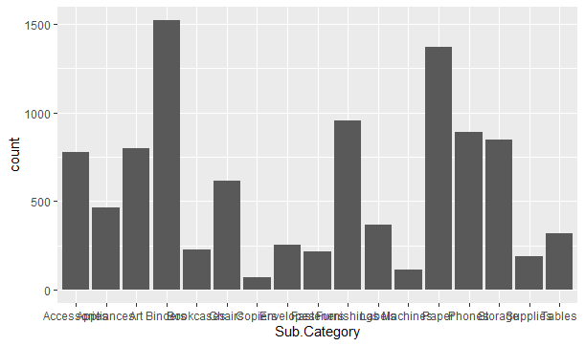

> bar+geom_bar()+theme_light()+

+ labs(y="Region",title="store")

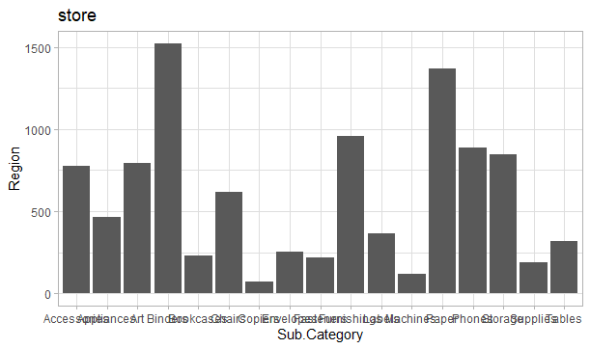

> bar<-ggplot(df,aes(x=Sub.Category,fill=Category))

> bar+geom_bar()

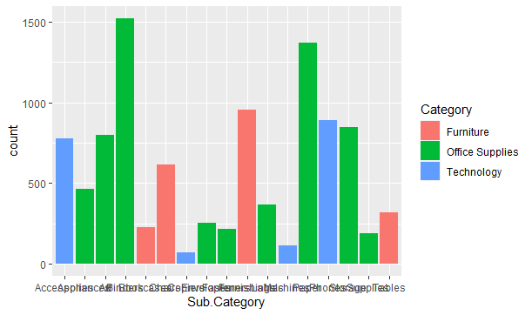

> bar+geom_bar()+theme_light()+

+ labs(y="Region",x="Sub.Category",title="store")

